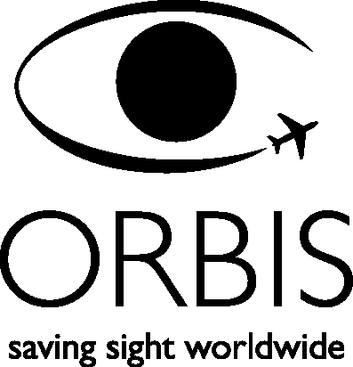

ASSOCIATE OPHTHALMOGIST

TERMS & CONDITIONS OF ENGAGEMENT

I, (print name:) release Project ORBIS International Inc. (hereinafter “ORBIS”), its officers, staff and program associates from responsibility for any accident, injury, sickness or death to me or any member of my family and/or loss of material items occurring as a result of participation. I understand and accept the personal health and safety risks involved in volunteering with this humanitarian cause.

ORBIS insurance does cover volunteer travel to/from program location site on commercial airlines in the case of accidental death or severe injury only. ORBIS will also provide emergency medical care while at program location site, including, if necessary, medical evacuation to your home country.

I understand I will be a guest of the host country, subject to the local laws and customs and, as a representative of ORBIS, maintain a professional image at all times.

I will be working under and subject to the authority of ORBIS’ local partner institution and/or ORBIS employed Project Director and agree to abide by his/her directives while visiting and working in the host country.

I appreciate ORBIS is dedicated to creating and maintaining a worldwide work environment that is free of harassment and understand all employees, contractors, consultants and volunteers are expected to adhere to this commitment. I will avoid any action or conduct that could be viewed as harassment, creating a hostile work environment, or constitute an affront to any religious, gender, racial or ethnic group.

I further give ORBIS my permission to use, reproduce, copyright, publish, and exhibit any and all photographs, videotapes or other means of reproduction of myself and/or voice, recorded or filmed, while participating during an ORBIS program without restriction to the date and future dates of use.

I have read, understood, and agree to the above assumption of responsibilities and conditions of this waiver.

Signed: Date:

