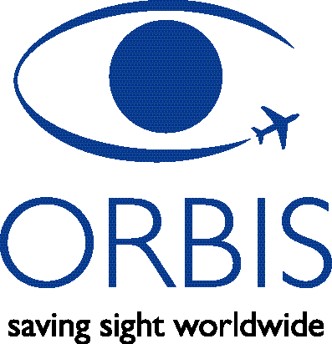
Flying Eye
Hospital
Application

Associate
Ophthalmologist

Please complete this form by type or write clearly in blue / black ink while placing special emphasis on how you would be helpful to an ORBIS DC-10 Flying Eye Hospital program.

Personal Details
Prefix | First Name | Middle Name |  | Surname | Suffix

Contact Details
Please supply ALL contact information & tick (√) the best method for ORBIS to reach you.
 | Tel work 1: |  | Work address:
 | Tel work 2: |  | Work address:
 | Fax: |  | Work address:
 | Tel home: |  | Home address:
 | Cell/Mobile: |  | Home address:
 | Pager: |  | Home address:
 | Email:
Preferred address to receive FedEx’s: |  |  | Work | Home

Present Employment / Professional Activity
Current Institution/Practice:
Current year in residency:
(if applicable)
List any position and/or title:
(if applicable)
Subspecialty of interest:
Would your institution be willing to sponsor your airfare while participating with ORBIS? |  | Yes | No

Volunteering Overseas
How did you hear about ORBIS?
Please tell us briefly why you would like to participate with ORBIS and if you have any experience working in developing countries.
Dates/periods of availability:
How much notice do you require? | < 3 months | 3 – 6 months |  | > 6 months
Languages spoken fluently: | English  Chinese (please specify):  French |  | German  Russian  Spanish  Other:

References
A letter of recommendation by your current Residency/Fellowship Director or mentor MUST be submitted with your completed application. Please provide your recommender’s details below:
Name:
Address:
Telephone:
E-Mail:

You MUST supply the following supporting documentation
with your application:

Required Documentation
A Letter of Recommendation from your Residency/Fellowship Director or mentor
Copy of your Medical School Diploma
Copy of your Residency Diploma (for fellows only)
Copy of your current State Medical Licence or Medical Registration Certificate
Copy of your Curriculum Vitae
Two passport photos
Copy of the information page of your passport (ID pages only, please)

Applicant’s Signature |  | Print Name |  | Date

Please return this form with the required documentation to one of our Volunteer Faculty recruiters:

Asha Sundararaman  Coordinator, Faculty Relations | ORBIS International  520 8th Ave.  Floor 11  New York, NY 10018
Email: asha@orbis.org | Tel: 646-674-5570 |  | Fax: 646-674-5598
Pauline Lam  Director, Faculty Relations, Asia | ORBIS-Hong Kong  Room 12, 1/F, Victoria Centre  15 Watson Road  North Point, Hong Kong
Email: pauline.lam@orbis.org | Tel: +852 2877-9373 | Fax: +852 2877-1297

Thank you for your time & interest.

